**SSN COLLEGE OF ENGINEERING**

**Department of Computer Science and Engineering CS6712 Grid and Cloud Computing Laboratory**

##### Assignment -8 : Creation of Virtual Machine Template, Installing C Compiler and Attaching Virtual Block

**Assigned Date: 21.08.2018. Due Date: 21.08.2018 & 23.08.2018**

1. Creating a Virtual Machine (VM) Template
   1. Use CentOS 6.5 (64-bit) OS image to create virtual machine template.
   2. Use “*onetemplate*” command to do it.
2. Update the VM template with SSH_PUBLIC_KEY using “*oneuser*” command.
3. Create a VM for CentOS 6.5 (64-bit) from the above created CentOS6.5 (64-bit) template.
4. Configure the local software repository using YUM Package Manager.
5. Install a C compiler (gcc) in CentOS6.5 (64-bit) VM and run a sample C program in VM.
6. Create a Virtual Block (DATABLOCK) using “*oneimage*” command.
7. Attach the created Virtual Block to CentOS6.5 (64-bit) VM using the below command.

oneadmin@localhost]$ *onevm disk-attach <vm-id> --image <virtual block name>*

1. Detach the attached Virtual Block in the above step from CentOS6.5 (64-bit) VM using below command.

oneadmin@localhost]$ onevm disk-detach <vm-id> <vm disk id>

1. Resizing the capacity of CPU & Memory (Scaling Up or Scaling Down) of Centos6.5 (64-bit) VM using following command

oneadmin@localhost]$ onevm resize <vm-id> --cpu <capacity> --memory

<capacity>

**Reference Commands:**

**In OpenNebula FrontEnd VM do the following.**

1. **Listing all types of virtual resources.** oneadmin@localhost]$ onehost list oneadmin@localhost]$ onevnet list oneadmin@localhost]$ oneimage list oneadmin@localhost]$ onetemplate list oneadmin@localhost]$ onevm list oneadmin@localhost]$ oneuser list oneadmin@localhost]$ onegroup list **Creating a host**

oneadmin@localhost]$ onehost create localhost –i kvm –v kvm -n dummy oneadmin@localhost]$ onehost list

**Creating a Virtual Network**

]$ cd /var/lib/one

]$ ls –l

]$ cat mynetwork.one NAME = “private” BRIDGE = br0

AR = [

TYPE = IP4,

IP = 192.168.0.100,

SIZE = 100

]

oneadmin@localhost]$ onevnet create mynetwork.one oneadmin@localhost]$ onevnet list

**Creating a Virtual Disk Images** [**www.opennebula.org**](http://www.opennebula.org/) **/ marketplace** Download the latest CentOS 6.5 with KVM Copy the link location

oneadmin@localhost]$ oneimage create - -name “CentOS-6.5_x86_64” - - path “Centos image location” - - driver qcow2 - - datastore default oneadmin@localhost]$ oneimagelist

1. **Creating a Virtual Machine (VM) Template**

oneadmin@localhost]$ onetemplate create - - name “CentOS-6.5” - - cpu 1

- -vcpu 1 - - memory 512 - - arch x86_64 - - disk “centos-6.5-x86_64” - - nic “private” - - vnc - -ssh

oneadmin@localhost]$ onetemplate list

1. **Update the VM template with SSH_PUBLIC_KEY using “*oneuser*” command.**

]$ cat /var/lib/one/.ssh/id_rsa.pub Copy the SSH_PUBLIC_KEY

]$ EDITOR = vi oneuser update oneadmin

TOKEN_PASSWORD = “b7 ”

SSH_PUBLIC_KEY = “paste the copied key”

// If it shows error do it as root user. In Opennebula-sunstone dashboard

Click on to settings - > right side, click public key and paste SSH_PUBLIC_KEY in the textbox.

Now you can login into CentOS VM without password.

1. **Create a VM for CentOS 6.5 (64-bit) from the above created CentOS6.5 (64- bit) template.**

oneadmin@localhost]$ onetemplate instantiate “Centos-6.5” - - name “CentOS-6.5 Virtual Machine (64-Bit)”

oneadmin@localhost]$ onevm list root@localhost]# gcc

To update password for root user

]# passwd

Changing password for root user. Password:

Retype password:

Go to openenbula-sunstone server dashboard

Click on to CentOS-6.5 VM and open VNC at right top Login as root user.

1. **Configure the local software repository using YUM Package Manager.**

]# cd /etc/yum.repos.d

]# ls –l

]# nano CentOS-Base.repo

]# vi CentOS-Base.repo

<add the centos download url in [base] section>

]# yum clean all

]# yum makecache

1. **Install a C compiler (gcc) in CentOS6.5 (64-bit) VM and run a sample C program in VM.**

]# yum install gcc –y

]# rpm –qi gcc Login as normal user

]$ vi hello.c

Write a sample hello world program in C

]$ gcc hello.c –o hello

]$ ls –l

]$ ./hello

Check the output.

1. **Create a Virtual Block (DATABLOCK) using “*oneimage*” command.**

]# fdisk –l /dev/sda

]# fdisk –l /dev/sdb PowerOff VM

oneadmin@localhost]$ onevm poweroff <vm-id> oneadmin@localhost]$ onevm list

Creating Virtual disk block

oneadmin@localhost]$ oneimage create –d 1 - - name data - - type DATABLOCK

- -size 20G - -fstype ext4

1. **Attach the created Virtual Block to CentOS6.5 (64-bit) VM using the below command.**

oneadmin@localhost]$ *onevm disk-attach <vm-id> --image <virtual block name>*

PowerON VM

oneadmin@localhost]$ onevm resume <vm-id> oneadmin@localhost]$ onevm list

1. **Detach the attached Virtual Block in the above step from CentOS6.5 (64-bit) VM using below command.**

]# fdisk –l /dev/sda

]# fdisk –l /dev/sdb PowerOff VM

oneadmin@localhost]$ onevm poweroff <vm-id> oneadmin@localhost]$ onevm list

Detach the datablock

oneadmin@localhost]$ onevm disk-detach <vm-id> <vm disk id>

PowerON VM

oneadmin@localhost]$ onevm resume <vm-id> oneadmin@localhost]$ onevm list

1. **Resizing the capacity of CPU & Memory (Scaling Up or Scaling Down) of Centos6.5 (64-bit) VM using following command**

PowerOff VM

oneadmin@localhost]$ onevm poweroff <vm-id> oneadmin@localhost]$ onevm list

Resize the capacity of CPU and Memory in a VM

oneadmin@localhost]$ onevm resize <vm-id> --cpu <capacity> --memory

<capacity>

oneadmin@localhost]$ onevm resume <vm-id> oneadmin@localhost]$ onevm list oneadmin@localhost]$ onevm show <vm-id>

**CREATING VM TEMPLATE AND VM DISK IMAGE**

###### AIM:

**EX NO: 8**

To create a VM template and VM disk image in Ubuntu 16.04 Desktop image.

###### PRE-REQUISITES:

1. Ubuntu 16.04 virtual machine image.
2. Open Nebula - front end installation (Refer ex 7 )
3. Download the centos6-5.4.qcow2c image file.

###### PROCEDURE:

**Switch the user to oneadmin and perform the following.** [$ sudo -i , $ su oneadmin ]

1. List all types of virtual resources.

###### $ onehost list

* 1. **$ onevnet list**
  2. **$ onetemplate list**
  3. **$ oneimage list**
  4. **$ onevm list**
  5. **$ onegroup list**
  6. 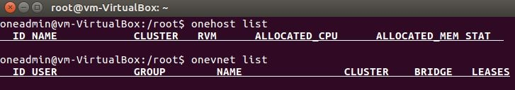**$ oneuser list**





Initially all the virtual resources are empty.

1. Creating a **host**

###### oneadmin@localhost]$ onehost create localhost –i kvm –v kvm -n dummy oneadmin@localhost]$ onehost list

1. **Creating a Virtual network**

Paste the following in mynetwork.one by opening it as **$ nano mynetwork.one**

###### ]$ cd /var/lib/one

**]$ ls –l**

**]$ cat mynetwork.one NAME = “private” BRIDGE = br0**

**AR = [**

**TYPE = IP4,**

**IP = 192.168.0.100,**

**SIZE = 100**

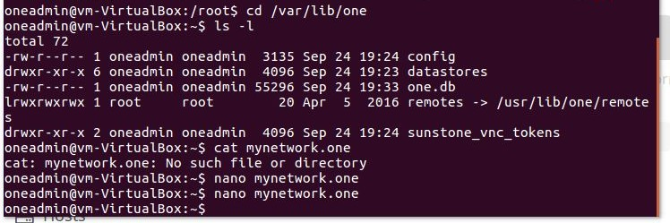**]**

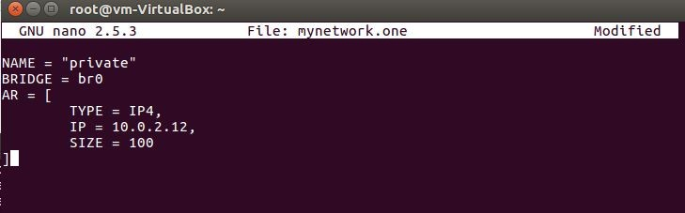

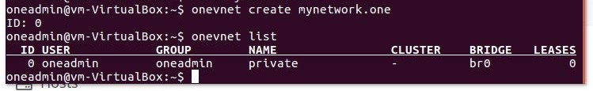**oneadmin@localhost]$ onevnet create mynetwork.one oneadmin@localhost]$ onevnet list**

1. **Creating a Virtual Disk Images**

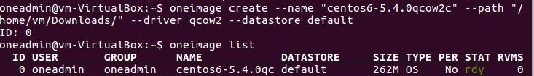**oneadmin@localhost]$ oneimage create - -name “centos6-5.4.0qcow2c” - - path “/home/vm/Downloads/” - - driver qcow2 - - datastore default oneadmin@localhost]$ oneimagelist**

1. **Creating a Virtual Machine (VM) Template**

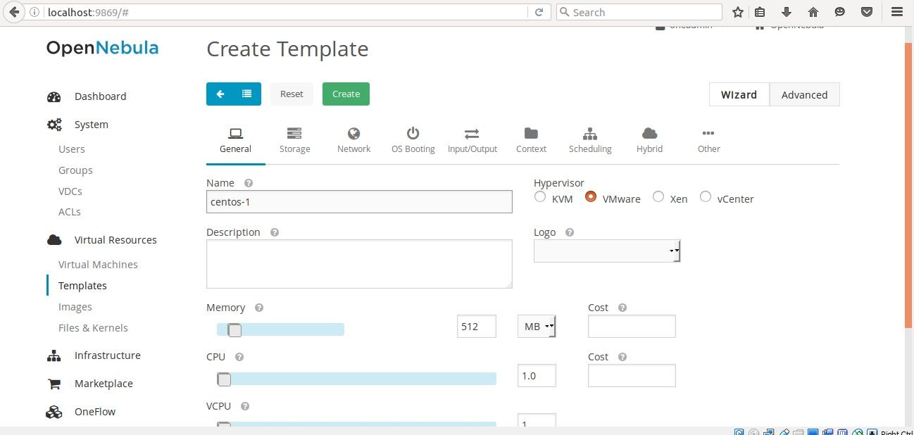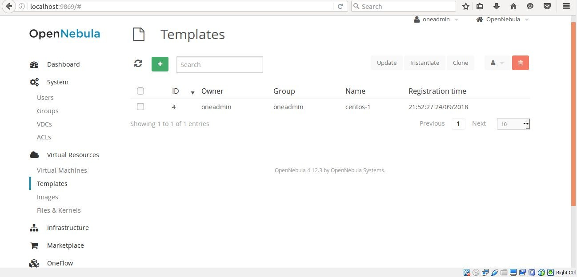One template can be created directly from the web interface by navigating to **templates under virtual resources in left pane options.Specify the name and leave the rest with the default value and click on create.**

###### (or)

**oneadmin@localhost]$ onetemplate create - - name “CentOS-6.5” - - cpu 1 - -vcpu 1 - - memory 512 - - arch x86_64 - - disk “centos6-5.4.0.qcow2c” - - nic “private” - - vnc -**

**-ssh oneadmin@localhost]$ onetemplate list**

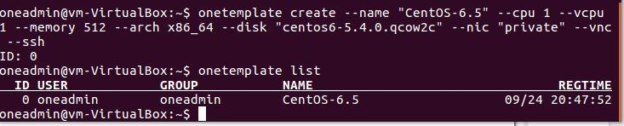

1. **Update the VM template with SSH_PUBLIC_KEY**

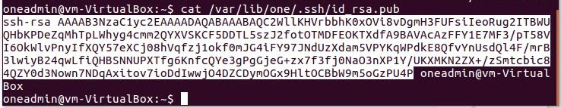Copy the ssh-rsa key from **/var/lib/one/.ssh/id_rsa.pub** file as shown and paste it in settings in open nebula sunstone server.

In Opennebula-sunstone dashboard Click on to settings - > right side, click public key and paste SSH_PUBLIC_KEY in the textbox. Now you can login into CentOS VM without password.

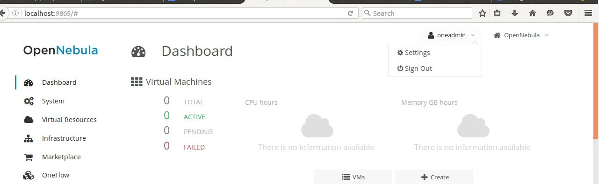

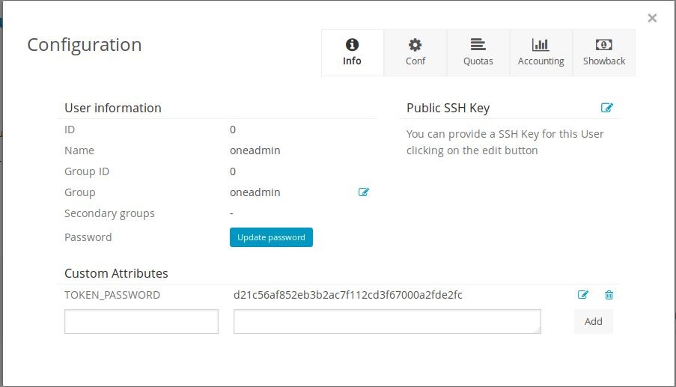

###### Create a VM for CentOS 6.5 (64-bit) from the above created CentOS6.5 (64- bit) template.

In open nebula sunstone server dashboard, goto **Virtual Resources > Templates > click on “Instantiate”** the following dialog box appears. Specify the vm name and click Instantiate.

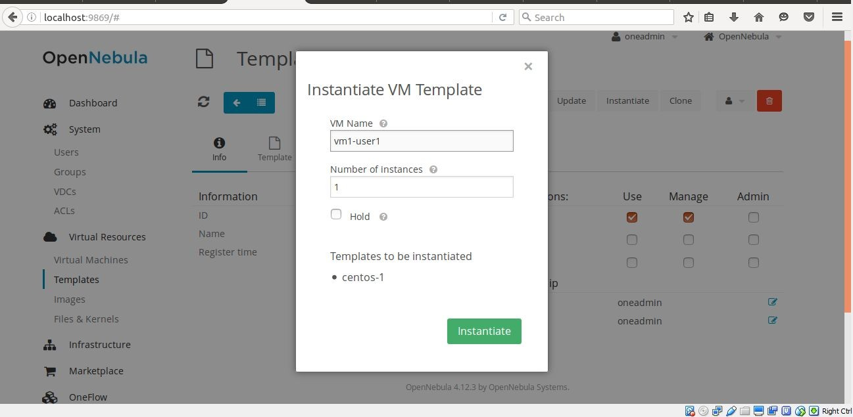

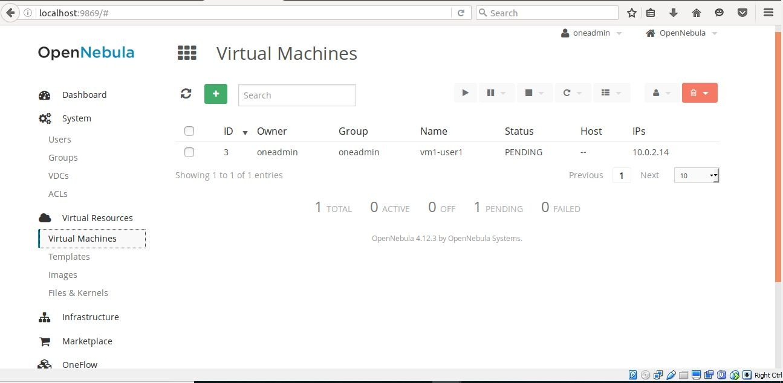The VM created can be viewed in the dashboard under the virtual machines tab.

It can also be listed through the command prompt using **$ onevm list command.**

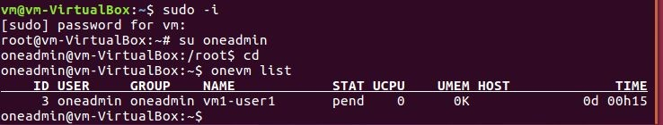

###### RESULT:

Thus, a VM template and VM disk image is created in Ubuntu 16.04 Desktop VM.